Once you get your partner’s image, list as many details as you can about it.

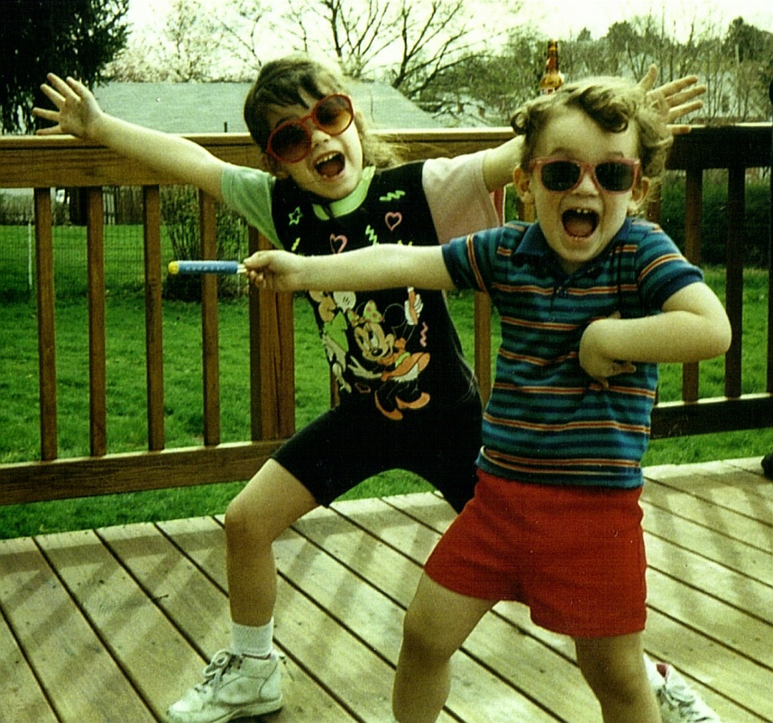

Then create your own dialogue for the image with at least FOUR sentences.

Descriptions of a photograph:
- Sister and brother
- Dancing on the deck
- Fall day
- Green grass, lack of leaves on the trees.
- Playschool thermometer in boy’s hand
- Sunglasses
- Mickey and Minnie Mouse
- Almost dusk

Sister: “Hey that dance move makes you look like an idiot!”
Brother: “Those glasses make you look like an idiot!”
Sister: “Well, at least I match!”
Brother: “Well, Mickey Mouse is for babies!”
Sister: “Whatever, you would know…”

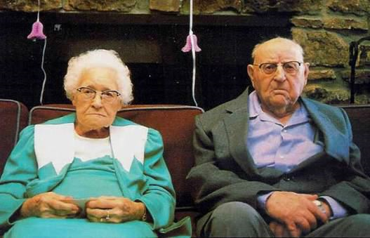

Now make as many observations as you can on this image and use some empathy if needed to create a fictional narrative on this image.

You may write in either first person as one of these two lovely folks or third person as someone else: near them, in the same room, taking the picture, a relative, etc.

Must be at least TWO paragraphs!
Create names and use TWO sentences with dialogue!

Totally, fictionally, appropriately, up to you! GO!

First Person Perspective

My wife, Ethel and I have been together for 50 years and I might not appear very happy right now, but I’ll get to that a little later. First off, I got all dressed up in this suit; Ethel thought it’d be a good idea to wear purple, and I must say I’m not a fan, at all, but that’s not why I’m aggravated, even though I feel like Shirley Temple in one of her purple lollipop garbs. Ethel and I are in a completely different state, in different weather conditions, around different people than we’re used to, who are crazy! But I’ll tell a little more on why we are here: Ethel and I decided to visit our grandson, and his new fiancée, in upstate New York. Now our grandson, Tom, our first born, is finally getting married! They got engaged two years ago and within that time they’ve moved away from our reach to New York. But times are different, not like in mine and Ethel’s time. When Ethel and I were young couples got engaged and married within a year. All our friends were married within a year after popping the question, just as we were. Ethel and I were engaged in the fall of September 1961 and married in March, one of the best days of my life. But today, Ethel and I are preparing for a rehearsal dinner with my grandson and his fiancée’s family. And I must say, it’s rather cold up here, compared to the small town Clarion, in Pennsylvania, where Ethel and I raised our six kids, including Tom’s mother, Grace, our first daughter. Besides the drastic temperature difference, things have been going okay so far. But my grandson, Tom, and his new fiancée, Jen, got us a room in the local Bed and Breakfast in this town (I can’t recall the name) where they’re getting hitched. Ethel and I were getting settled the first night but when we went to hit the rack, the bed slowly deflated underneath us. I mean we laid down and the bed, bed frame, and mattress just gave under our weight, at least a half a foot lower to the ground. Let’s just say we weren’t too secure in sleeping in it all night. But my Ethel needed her beauty sleep. I finally nodded off around 3 AM after I made sure she was asleep and sound for good. That didn’t last long though, because around 5 AM, I wake up to hear Ethel screaming, “Nester! Nester! There’s a spider on your stomach!” I love my wife but I really could’ve used that sleep after the seven hour drive up to this forsaken place. I looked down at my stomach to find a decent sized spider walking up my chest. I smashed it and left it and went back to sleep. But shortly after killing the cursed thing, I felt Ethel wipe it off my chest and make her way to the bathroom. Needless to say we didn’t have a very welcoming stay, in the beginning, and after meeting Jen’s parents we were definitely not feeling too well about this rehearsal dinner.
My wife had made a few things to say for Tom and Jen at their rehearsal dinner. Ethel has always loved to write and wrote a few things down, I don’t know, quotes and such. She was so excited to read them to her grandson and new potential granddaughter because she’s had them written since they were first engaged. Ethel and I got ready in our wretched room, her wearing her beautiful teal dress suit and me my purple under shirt, she packed for me. I remember watching Ethel put on her wedding band and the watch I had recently got her for our golden anniversary and thought how lucky I am. Maybe it was this wedding and our recent anniversary because I try not to be too sentimental. Anyway, as we went down to the lobby to wait for Grace, Tom’s mother, to tell us were the dinner was, Jen’s parents roll on in, wearing denim matching suits. Literally, both in the same outfit! I mean it looked like they had on Levi’s head to toe. Now I love Jen, and have known her for a while, but this was a little odd to me. The oddity continued. Jen’s parents, Rita and Daniel, who preferred to be called Daniel, I may add, started stretching in the lobby to “get ready for this dinner.” Then they proceeded to divulge every person waiting in the lobby for the dining room to open: introducing themselves, screaming at the top of their lungs about their daughter’s rehearsal dinner in twenty minutes, taking sips of other peoples water, while they wait, and giving everyone high fives like they were a part of the family already! Rita and Daniel, of course had to meet the “grandies” as they called us, and acted as if we were glass. They barely shook our hands and screamed at us like we were deaf. I mean Ethel and I are pretty up there but neither of us have hearing aids yet, and I must say Rita is louder than the bombs from the shores of Normandy. She eventually took out her digital camera, I don’t understand those things for the life of me, why would someone want to wait for a picture to print when they could just get a good camera, like a Polaroid and get their picture instantly? I hate waiting. Anyways, Jen’s mother started snapping pictures of everything, my Gracey and her husband Todd, the Bed and Breakfast lobby, everything… They were “documenting the occasion.” This is where the picture of Ethel and I came from: Ethel holding her index cards with words of love for her grandson and soon-to-be wife, and me surveying the loonies in front of me, thinking, “My, have times changed...”

